High-Speed SRAM Cache

Billy Chantree, Daniel Sosa, Justin Ferrante
ECE 432 – Fall 2007
University of Virginia
bsc3f@virginia.edu, dps9s@virginia.edu, jaf5j@virginia.edu

ABSTRACT
In this paper, we describe the design and simulation of a high speed 64-kilobit SRAM cache. This project was undergone demonstrate the knowledge and expertise of our company to the Portable Instruments Company (PICo) board.

INTRODUCTION
This memory was designed as an array of memory blocks. The full array consists of 32 two-kilobit blocks connected to external inputs, namely the address bits to be accessed (ADDR<N-1:0>), the 32-bit data word to be written in the event of a write operation (Din<31:0>), as well as READ, WRITE, and CLK control signal bits. The blocks are composed of 2,048 identical bitcells and associated external components (decoders, sense amps, etc.). V_{DD} for this design is nominal at 5 volts, and the minimum CLK period allowable is 6 nanoseconds.
Each block has its bitcells arranged into 64 rows and 32 columns, thereby allow for the storage of a single 32-bit word across each row for a total of 64 words stored per memory block. We chose this particular arrangement for two reasons: 1) The smaller the block size, the quicker access time would be (due to shorter path propagation time), and 2) Having each row consist of a single word makes the memory word-addressable. In this way, an entire 32-bit word can be written or read over the course of a single cycle (i.e., 32 single bit reads/writes can occur simultaneously). As of a result of this design strategy, data that is being written in or read out can be routed in parallel via bus lines, greatly speeding up operation time.

BITCELL DESIGN
A standard 6-transistor design composed of two cross-coupled inverters and two NMOS pass transistors is used for the bitcells in this project. Consult Figure A at the end of this document for a Cadence schematic detailing our 6T bitcell. This schematic demonstrates the basic structure and functionality of the bitcell design. Furthermore, a finely detailed physical layout of the bitcell showing the different layers (metals, poly, wells, connections, etc.) is also included as Figure B at the end of this report. This layout serves the purpose of providing fabrication-level details of our bitcell design, the most important being area consumed.

Bitcell Sizing
The transistors labeled M1 and M3 (the pull-down NMOS transistors within the inverters) are three micrometers wide and six-hundred nanometers long. The transistors labeled M2 and M4 (the pull-up PMOS transistors within the inverters) are 1.5 micrometers wide and six-hundred nanometers long. The transistors labeled M5 and M6 (the NMOS pass transistors into the bitcell) are 1.5 micrometers wide and seven-hundred fifty nanometers long.
To arrive at these choices, Cell Ratio and Pull-Up Ratio calculations were used as follows:
CR = (W₁/L₁) / (W₅/L₅)
PR = (W₄/L₄) / (W₆/L₆)
With our chosen values, CR = 2.5, and PR = 1.25. This yields a cell ratio greater than 1.2, and a pull-up ratio below 1.8. These values are necessary to keep our read stable while retaining the ability to write to the cell, all while keeping individual bitcells to a reasonable size.
When these values are used, the minimum size bitcell obtained is 25.2 microns across, and 8.85 microns high. This is including any contact points and metal strips laid across the cell for functionality that may overhang the transistors that compose the device.

Bitcell Operation
Each bitcell has as its inputs a wordline (WL) and two bitlines (bitline and bitline bar, denoted as BL and BLB, respectively). The WL signal is connected to the NMOS pass transistors and serves to enable a read or write operation by opening access to the bitcell’s internal cross-coupled inverters, while the bitlines contain the data that is read or written to the cell.
To write a value to the cell within the block, the bitlines are both precharged to V_{DD}. A write driver then discharges one of the bitlines so that the proper values are presented on the BL/BLB pair. The WL signal is then asserted long enough to write the desired value into the bitcell (usually 1 nanosecond or so). The bitlines are then precharged again at the end of the cycle, and the cell is now ready for the next operation.
To read a value in a cell in the block, the bitlines are both precharged to V_{DD}. The WL signal is then asserted, and one of the lines begins to discharge. This bitlines are then fed into a sense amplifier for processing. The sense amplifer’s output is then sent to the output of the block, and the bitlines are precharged to V_{DD} again.

Operation Specifics
As mentioned before, a reasonable sizing ratio between M1/M5 (CR = 2.5) and M4/M6 (PR = 1.25) was implemented to prevent read and write upsets from occurring due to inter-cell transistor fights. M5 and M6 were designed to be minimum size to save area, since delay time will not be significantly affected by using smaller transistors. The WL signal acts to drive the gates of the two NMOS pass transistors which opens up the cross-coupled internal nodes for reads or writes.

SENSE AMPLIFIER DESIGN
The sense amplifier consists of cross-coupled inverters with the junctions between NMOS and PMOS transistors connected to the drain terminals of pull-up PMOS transistors whose gates controlled by an enable signal. In this way, the sense amplifier resides in a “precharged” state when it is not active. The source terminals of the NMOS transistors within the inverters are then connected to the drain terminals of NMOS transistors with gates connected to the two bitlines (i.e., BL and BLB). These NMOS transistors have their sources connected to the drain of a final NMOS transistor, with gate controlled by the aforementioned enable signal. This additional NMOS transistor also serves to maintain the “precharged” sense amplifier state when inactive. See Figure C for a Cadence schematic of this design.
Each column within a block has one sense amplifier attached in order to handle read operations. This particular 9-transistor voltage sense amplifier was included in our design for its simplicity and ease of use. Multi-stage sense amplifiers were considered in our proposal to help minimize delay, but due to their complexity and area-to-delay tradeoff, we decided against it.
Current sense amplifiers were the ideal choice for our high-speed cache design, due to their high speed. Unfortunately, we were unable to secure the time or resources to implement these into our SRAM.

Sense Amplifier Operation
The sense amplifier is designed to speed read operations by sensing a differential voltage on the bitlines and reading the value without requiring rail-to-rail voltage swing on BL/BLB.
The sense amplifier is enabled after the WL signal has been asserted and one of the bitlines has begun to discharge. The cross-coupled inverters within the sense amplifier then transition to the desired output values very quickly, slamming the “new” BL/BLB pair to their respective rail-to-rail values. The output values are taken from the internal junctions between the two inverters. The read operation is free to terminate once these output values have been passed out of the block and latched into the proper output register. To end the read cycle, the precharge control signal is again asserted and the bitlines rise to V_{DD}.
The use of efficient sense amplifiers serves to reduce power dissipation and read cycle time, allowing for faster clock periods (since reads are slower than writes).

Operation Specifics
While the sense amp enable (SAE) signal is low, the cross-coupled inverters from which BL/BLB are read are driven to a metastable point (i.e., both internal nodes are pulled up to ~2.5V). This can be labeled as the “precharge” phase. Once the enable is applied, the precharge stage ends and the bitlines are free to drive the pass transistor gates of the sense amplifier. As the voltage difference between the two bitlines increases to ~1V, the internal cross-coupled inverters become more and more biased until they slam to the rail-to-rail values, locking the read output into place and making it available for output. Total propagation time for this device is found to be on the order of 2.0 nanoseconds, start to finish.

DECODER DESIGN
Both 5 to 32 and 6 to 64 decoders were constructed in a hierarchical manner by reducing each output combination to multiple stages via De Morgan’s laws.
A Hierarchical design was chosen for our decoders. This enables a simultaneous decrease in area and delay. Although a dynamic NAND implementation could have been chosen for decreasing delay, its increase of power and area made it a poor choice for this project. An implementation using 6 input AND gates was briefly considered and then discarded due to quadratic increase in delay with fan in. In the chosen design, a buffer was inserted for every four gates driven to reduce fan out.

Operation Specifics
For this design, an enable signal is necessary due to timing constraints and to save power when not in use. This logic is implemented in the first stage of the final buffer in order to reduce the propagation delay of disabling the decoder. This also reduces power by reducing switching activity through the larger transistors that appear later in the buffer. However, it bypasses the delay from the high logical effort of the earlier stages.
A 3 stage inverting buffer used at the end to drive wordlines is comprised of progressively larger inverters in order to equalize delay.

WRITE DRIVER DESIGN
Consult Figure D for a detailed schematic our team’s latch-style writer driver design. The writer driver consists of two basic stages: 1) The preliminary logic section and 2) The driving section.
Within the preliminary logic portion, a sequence of logical gates (NOTs and NORs) are used to manipulate its input values (WRITE and DATA) in such a way that while WRITE is high, the DATA value will be driven onto a given pair of BL/BLB nodes. This logic was designed to involve the minimum amount of gates (and thereby, transistors) necessary, consisting of merely two inverters and two NOR gates for a total of 12 transistors.
Once the correct data pairing has been resolved by the logic section, these BL/BLB values are fed into the 24-transistor driver section which consists of inverter logic and buffering stages. Namely, incoming BL/BLB signals and their complements are connected to the gates of opposing inverter PMOS/NMOS transistors, thereby ensuring that the BL/BLB final outputs are latched and indeed logical opposites of one another. Once these output values are established, the signals are buffered up high enough to quickly drive a given BL/BLB load (i.e., ~1 nanosecond to achieve rail-to-rail values).
This particular write driver design was chosen for primarily for its simplicity, reliability, and speed. It uses requires a small number of transistors (36 in all, including buffering stages) and provides a reasonably short propagation delay time of about 1.5 nanoseconds from its inputs to its outputs (i.e., WRITE and DATA to BL/BLB). The most mitigating factor to delay for this particular design was the buffering stage, which had to be large enough to handle a BL/BLB load.

Write Driver Operation
The write driver is designed to apply the correct data values to a given bitcell’s BL and BLB lines. It is sized large enough to quickly transition these BL/BLB nodes to their rail-to-rail values.
The write driver is enabled as soon as a write operation has been initiated (i.e., WRITE goes high). The corresponding data value for that particular block column is driven to the BL (and its compliment to BLB), after which WL is then engaged to open up the proper bitcell. These bitline values are then free to toggle the cross-coupled inverters within the bitcell, after which the WL is dropped and the write operation is complete.
The use of efficient sense amplifiers serves to speed up write cycle times by minimizing the amount of time it takes to insert new values into bitcells.

Operation Specifics
In the preliminary logic stage, a pair of two-input NOR gates are used to resolve the bit line values. The inputs to these two NORs are WRITEBAR/WRITEBAR and DATA/DATABAR, respectively. In this way, the NOR gate with both inputs equal to 0V will elicit a high output of 5V, which in turn will drive the outputs of BL/BLB to 0V/5V, respectively. Total propagation time through this device is found to be on the order of 1.5 nanoseconds, start to finish.

CONTROL LOGIC DESIGN
In order for our SRAM memory design to work correctly, a set of synchronized control signals had to be established. These signals regulated the enabling of a number of internal signals (e.g., PRECH, write driver, WL row decoder/driver, etc.), and are generated using known input control signals, namely READ, WRITE, and CLK. These control signals serve the purpose of coordinating arrival and departure times of signals necessary to pull off read and write operations on bitcells within a memory block. Pulse generation and buffering are the key components to the design of these special control signals.
Descriptions of the major logic controlling devices are featured below. Additionally, consult Figure E for a timing diagram of how the different control signals within a memory block are designed to arrive within our team’s architecture for each operation type.

Precharge Signal Generator
This particular component is used to regulate the precharge phases of the 64 BL/BLB pairs within a block. Depending on which operation was being applied (read or write), the initiation time and duration of the precharge phased need to vary.
For a write operation, no initial precharge phase is necessary since the writer driver will be driving the BL/BLB values rail-to-rail anyways. However, an extended precharge phase is necessary following a successful write since one of the BL/BLB lines must be restored to VDD from a full-swing value (i.e., 0V up to 5V). Thus, using pulse generation logic and buffering/enable stages that can be viewed in Figure F attached to the end of this report, a sufficiently long precharge phase (~4.0 nanoseconds in duration) is established for a write operation.
The circuit path for a read operation works in much the same way, the key difference being that the precharge pulse width can be reduced since the BL/BLB line pairing is being restored from ~4V, not 0V. Thus, the pulse generation logic is adjusted to create a less lengthy pulse width (~3.0 nanoseconds in duration) and to arrive at a later time (after the sense amplifier output has been secured and read out).

Write Driver Controller
This circuit device is used to regulate when to open and close the switch the between the write driver and the BL/BLB pairs. The enable signal begins to propagate as soon as the write operation is received and is designed to terminate once the bitcell has attained the desired data value (i.e., once the WL has been on long enough, ~1.0 nanoseconds).
Using pulse generation logic along with some other logical gates (in much the same way the precharge signal generator was designed), a write driver enable pulse of 2.0 nanoseconds was established beginning when driven data from the driver first appears to when the data value is latched into the correct bitcell.

Word Line Controller
The word line controller was created to regulate when and for how long a given WL signal pulses high during a read or write operation. As the signal timing turned out, the pulse requirements for both operation types (i.e., both read and write) were identical. The amount of bitcell access time needed to ensure that a read or write has been pulled off successfully is 2.0 nanoseconds, which is achieved by our word line controller design. The WL is timed to pulse high either after the BL/BLB data values have been driven sufficiently (during a write cycle) or after an initial precharge phase has completed (during a read cycle).
In much the same way as the precharge and writer driver controllers, creation of this enable signal is achieved by using pulse generation in conjunction with logical gates.

BUFFER DESIGN
Buffering stages (better known as a series of inverters) are implemented throughout our SRAM design, either as a means of boosting the number of inputs a given output can drive (i.e., FANOUT) or merely as a means of delaying signals for synchronization purposes (i.e., introducing propagation delay).
The most prominent buffering stage used for signal boosting can be viewed in Figure G, attached at the end of this report. Typically, a FANOUT of 4 is desired and this buffer design indicates no exception. Specifically, this particular buffer was used to augment the precharge and write driver signals enough to drive their respective loads (for precharge, 64 column pass transistors; for write driver, BL/BLB). Smaller variations of this buffer design, with smaller FANOUT values, are used intermittently throughout our memory blocks (e.g., to drive a larger-than-normal transmission gate or only a relatively small number of inputs that would otherwise take too long to do).
As for delay buffers, these were specifically designed to be minimum size to provide a standardized interval of delay for each inverter pair introduced. These buffers were only used to correctly space control signal propagation times within a read or write cycle.

SIMULATION RESULTS
The simulations have consisted of writing in a 32 bit word consisting of all zeros, and then reading those values back after the write cycle completes. The design has successfully output the desired 32 bit word. The final block design can be seen in Figure H.
These simulations assume that the incoming word is going to present for the entire clock cycle. The output data at this stage is not latched, though it is high for between 1 and 2 nanoseconds, which would be long enough to write to a register. Once the values are latched to registers, the data will be easily accessible as the output of the SRAM.
At TT values, we achieved the desired results for writing and reading an entire word to the SRAM. This is shown in Figure I, with a 32 bit input word consisting entirely of zeros. The figure itself shows one bit of this word. When the entire word is simulated the same output is achieved for each bit, though that graph has been omitted here in order to better show the operation of the memory.

ROOM FOR IMPROVEMENT
At this stage, this group does not have functioning registers to latch the value read from the SRAM. By the time this group demonstrates the SRAM in the lab, we hope to have registers to properly latch the output value.
Once we establish a working system to latch our outputs, we could potentially shorten read cycles by shortening clock period. This depends on the set-up and hold times required by the latch. Depending on the amount of time the input vector is available, we may or may not need to add latching functionality to the front end of the SRAM to ensure proper writing.
At this stage, we have a functioning block decoder that is not yet connected to the entire SRAM array. By the demonstration time we hope to have this component connected and functioning as desired.
Current sense amplifiers were a part of our research and design effort, however, due to a lack of time and resources we were unable to design a functioning example, and so used our design utilizing cross-coupled inverters.

METRIC
Featured below in Table 1 is the metric data required in the project specification.

Table 1: SRAM Design Metric
Delivery Item | Value | Units
metric | 710018948.5 | Watts*ns^2*um^2
bitcell area | 14,615,838.72 | um^2
total area | 15,601,383.18 | um^2
read power | 1.233 | Watts
write power | 1.42 | Watts
total power | 1.264166667 | Watts
read delay | 6.0 | ns
write delay | 4.5 | ns
total delay | 6.0 | ns

ACKNOWLEDGMENTS
A special thanks to our professor Benton Calhoun and his wonderful teaching assistant staff, Devendra and Jiajing., for giving us the opportunity to test our knowledge of IC design.

REFERENCES
- Alowersson, J., and Andersson, P. A 35 Gbit/s Throughput 64 kbit CMOS Buffer SRAM. Swedish National Board for Technical Development.
- Arsovski, I. High-Speed Low-Power Sense Amplifier Design. ECE1352 – Analog Electronics Reading Assignment. 12 November 2001.
- Ney, A., Girard, P., Landrault, C., Pravossoudovitch, S., Virazel, A., Bastian, M. Slow Write Driver Faults in 65nm SRAM Technology: Analysis and March Test Solution. Laboratoire d’Informatique, de Robotique et de Microelectronique de Montpellier – LIRMM Universite de Montpellier II / CNRS.
- Yun, K. Memory. Adapted from EE271 Notes, Stanford University, Palo Alto, CA.

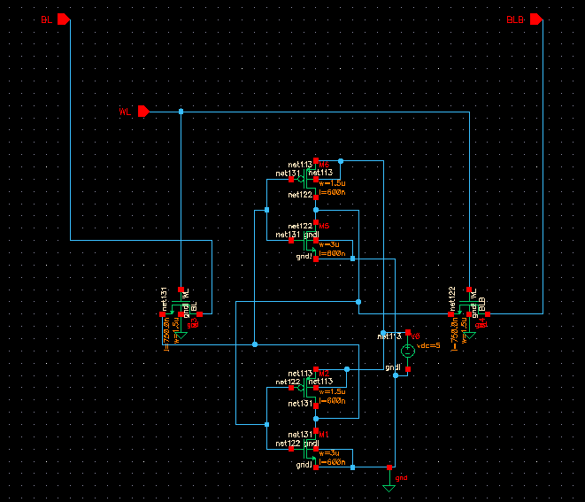
Figure A: 6T Bitcell Design

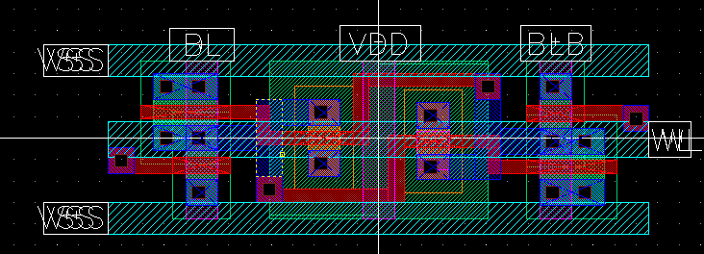
Figure B: 6T Bitcell Layout with Contacts

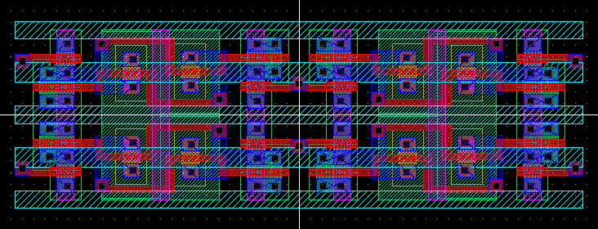
Figure B.1: Layout consisting of four bitcells showing manner of connection.

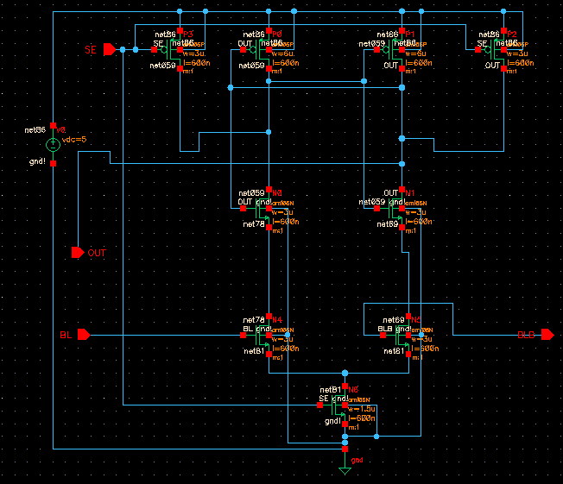
Figure C: Sense Amplifier Design

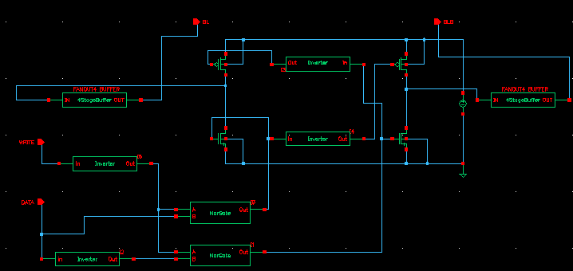
Figure D: Write Driver
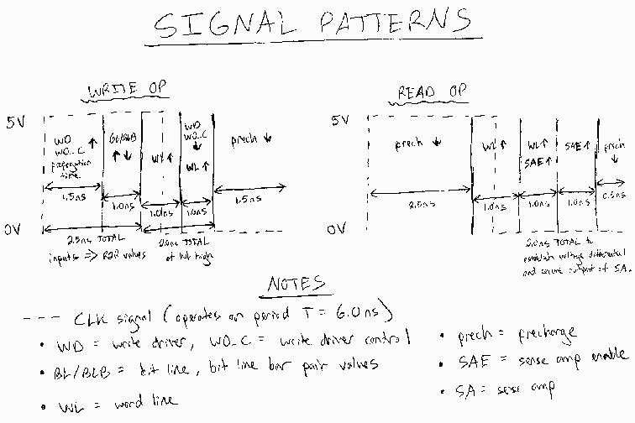
Figure E: Timing Diagram

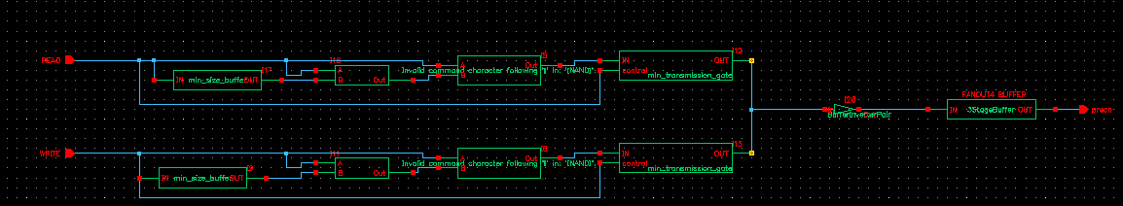
Figure F: Precharge Generator
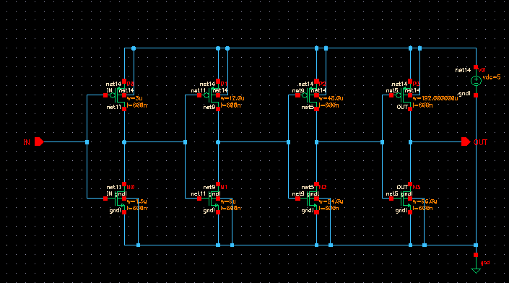
Figure G: Buffer
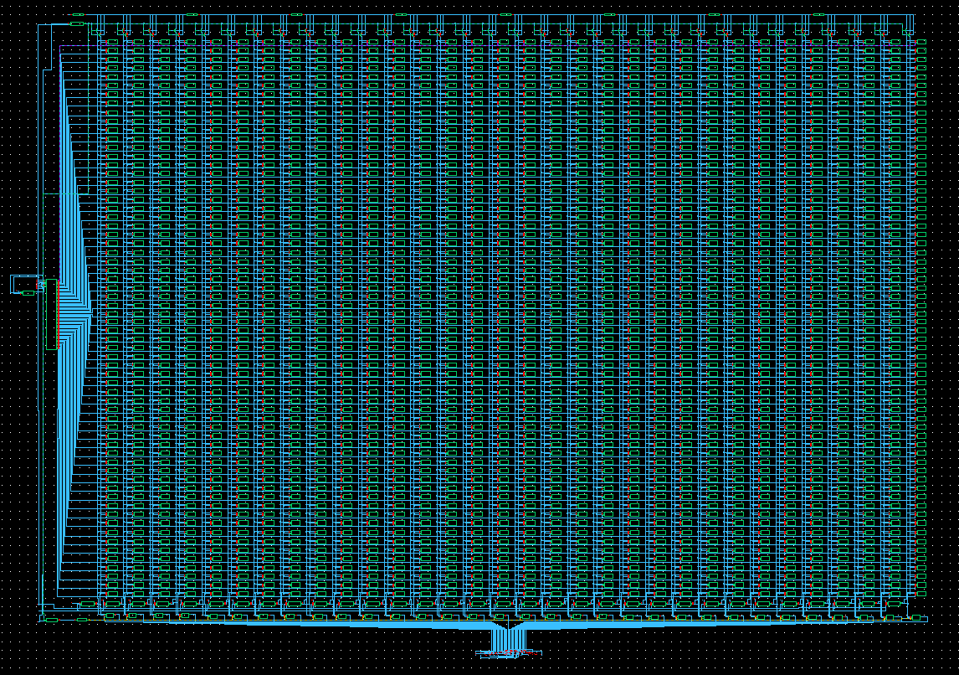
Figure H: 2,048 bit SRAM block
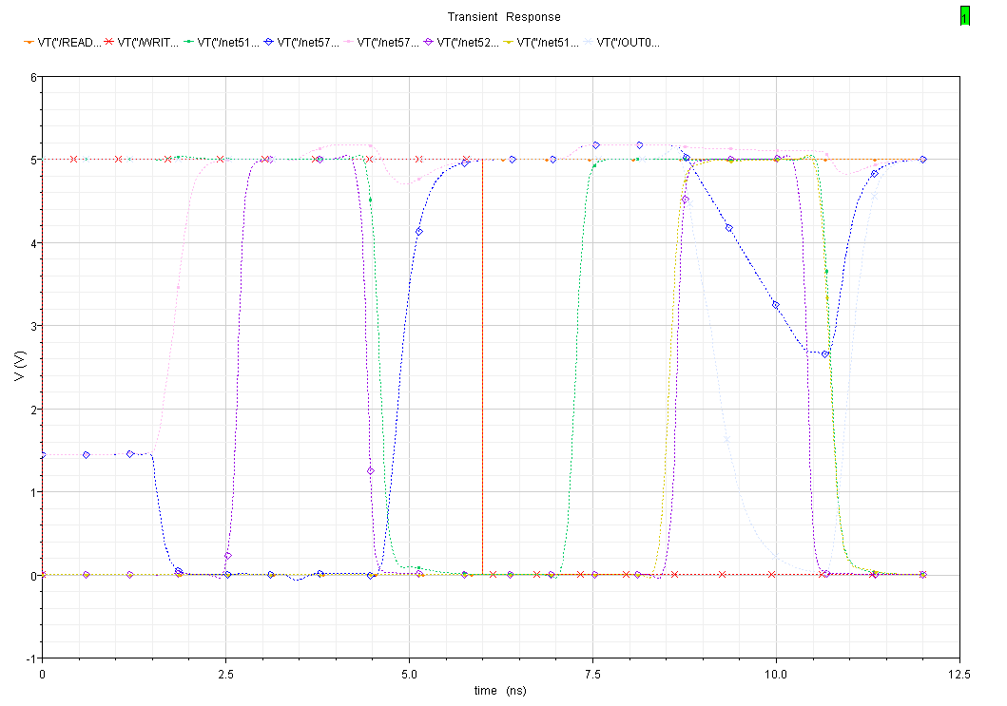
Figure I: Simulation of Writing and Reading a zero from the SRAM

